Free Youtube views for an unlimited number of your videos! Boost your video's popularity using their simple and free method! Or, buy Youtube views and other services here.

[ythunder.com](https://ythunder.com/) has free & open registrations.

While it’s not totally impossible to earn hundreds of thousands of dollars just by uploading a video of your little kid being his usual charming self, it’s close to impossible to earn tons of money just by maintaining a presence on [YouTube](https://ythunder.com/). Sure you can make money, but don’t count on it Free Youtube views：[ythunder.com](https://ythunder.com/)

to get you out of your day job.

It’s tough to make a living off [YouTube](https://ythunder.com/), and if your idea of earning [YouTube](https://ythunder.com/) money revolves around monetization of your videos then it’s certainly going to take a while before you see real profits.

Don’t despair, though. There are actually several ways you can earn money via [YouTube](https://ythunder.com/). [YouTube](https://ythunder.com/) is the second largest search engine after Google and this gives it huge potential. It is also the second most visited site in the world and traffic, while it’s something we all hate on the road, is most desired on the web.

**So, there’s already traffic on** [**YouTube**](https://ythunder.com/) **and all you have to do is tap into a tiny portion of that to start earning money**. Here are 5 profitable strategies that will let you do just that.



1. Drive traffic to your website

If you have a business and you have a website, you can use [YouTube](https://ythunder.com/) to funnel your video traffic to your website. It goes Free Youtube views：[ythunder.com](https://ythunder.com/)

without saying that your videos should generate interest in viewers, so that you actually have people to direct to your site.

**One of the easiest and most effective ways to attract viewers to your videos is by buying** [**YouTube Views**](https://ythunder.com/). Your videos will have higher visibility both on [YouTube](https://ythunder.com/) and on Google. Popular videos get first in line for suggested videos and rank high on Google SERPs. You’ll also gain more organic views because your audience will see your Views counter as a recommendation of the worthiness of your video. In short, your video must be good if there are a lot of people watching it.

Now, to direct your [YouTube](https://ythunder.com/) viewers to your website, add your site as an “associated website” in your [YouTube](https://ythunder.com/) channel so you can start linking your website directly from your video.

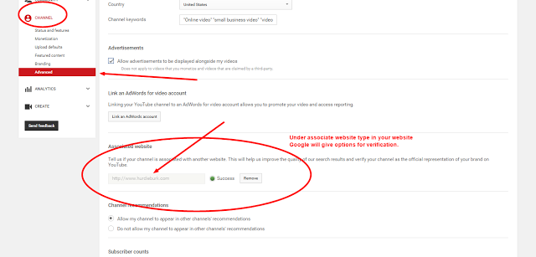

Image credit: HurdieBurk

You can then link to your website using the Cards function. Go to your Video Manager, click Edit on the video you want to use, then select “Cards.” Once you’re on the “Cards” tab, just choose the associated website you want to appear on the video. You’ll have to set up an associated website beforehand, too.

When you can successfully convert some of your [YouTube](https://ythunder.com/) traffic to your website, there are quite a few ways you can make use of that traffic to earn money. The two most popular monetization practices are Google AdSense and Affiliate Programs.

**Google AdSense**

AdSense places ads on your website, and you’ll get paid when they’re clicked by your visitors. This marketing campaign is generally known as Pay-Per-Click.

Google AdSense is free to join and the ads that you’ll be getting will be relevant to the content on your website.

**Affiliate Programs**

Join affiliate programs from several companies and advertise their products on your site. As an Affiliate Marketer for the company, you’ll get a percentage of the sales when a customer buys because of your marketing.

Most online marketers who are earning passive income from their websites started with affiliate marketing.

2. Promote your own products on [YouTube](https://ythunder.com/)

Sell your own products and use [YouTube](https://ythunder.com/) to promote them. Do a “How-To” video demonstrating how your product works. Gather video testimonials from your clients or run a contest.



Don’t forget to tell your viewers where they can click to learn more about your product or even where to make a purchase.

3. Drive traffic to your affiliate programs

Aside from your website, you can also use your [YouTube](https://ythunder.com/) channel for affiliate marketing. If you don’t have products and services, direct your viewers to your affiliate’s website and promote their products.

Don’t forget to use your affiliate links to make sure you get the commission on any sale resulting from your video marketing. Use your affiliate links when you’re adding Cards to your videos.

4. Join the [YouTube](https://ythunder.com/) Partner Program

When you’ve been on [YouTube](https://ythunder.com/) for at least three months and have built a large enough subscriber base, you can join [YouTube](https://ythunder.com/)’s Partner Program where, as long as you’re eligible, you’ll be able to make money from the ads they’ll put on your videos.

Enable monetization on your channel to set-up your account and sign up for Google AdSense to set-up your payment information. Make sure you own the rights to your videos and that the program is available in your country.

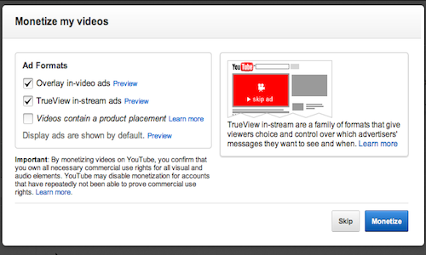

**Take note that you don’t get paid for the views on your videos but for the clicks and views on your ads.** Advertisers also only pay for ads viewed for at least 30 seconds. This is why you’ll hardly see any money if you only rely on video monetization without using the other tactics we mention.

5. Build your brand and attract sponsorships



Work on becoming a [YouTube](https://ythunder.com/) superstar and attract sponsorships! A [YouTube](https://ythunder.com/) superstar is akin to a mainstream media celebrity who can get paid to advertise brands and products. The difference is that you’ll be doing it on your [YouTube](https://ythunder.com/) channel.

When you’ve built a successful [YouTube](https://ythunder.com/) Channel, offers will pour in and as long as you command a high viewership, you can negotiate for a good price.

Becoming a [YouTube](https://ythunder.com/) superstar is not an easy feat, but if others can do it, why can’t you, right? Study the channels of popular [YouTuber](https://ythunder.com/)s and see how you can learn from them.

Remember, you can also [buy YouTube views](https://ythunder.com/) to kickstart your channel’s success. Bought Views, while not organic, will help make your videos appealing. People follow the crowd and it’s a science proven to be effective in marketing campaigns.

Think about it, if you’re given the choice between a popular video on [YouTube](https://ythunder.com/) and an unpopular one with a number of views you can count on your fingers, which would you watch? Most people would go for the popular video.

**So it’s true,your bought views will eventually give you authentic views and real interest from other users**.

Start Making Money Today!

Go ahead and sign-up for [YouTube](https://ythunder.com/) if you haven’t yet. Take advantage of the billion views [YouTube](https://ythunder.com/) gets each day.

You can supplement your income with money you earn from [YouTube](https://ythunder.com/). However, if your goal is to make a living from your videos, it’s going to take a lot of time and effort from you. **Still, you have to start somewhere and today is as good as any to start building your name on this most popular of video platforms.**

You can do it!



Free Youtube views for an unlimited number of your videos! Boost your video's popularity using their simple and free method! Or, buy Youtube views and other services here.

[ythunder.com](https://ythunder.com/) has free & open registrations.